

דַּיָּג

|  |  |  |  |  |
| --- | --- | --- | --- | --- |
| דָּג | דַּיְסָה | דָּג | חַכָּה | דַּיָּג |
| מַלְכָּה | דַּיָּג | גַּל | דַּיְסָה | חַכָּה |
| גַּל | דַּיָּג | חַכָּה | קְעָרָה | דָּג |
| חַכָּה | זָהָב | מַלְכָּה | דַּיָּג | גַּל |
| דָּג | חַכָּה | דַּיָּג | דַּיְסָה | דַּיָּג |

[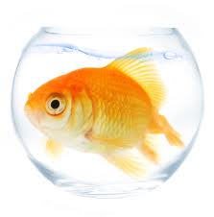](http://images.google.co.il/imgres?imgurl=http://www.masa.co.il/_content/images/0111fb88eaf12f81b38b1a2d6a24dd9f_goldfish__amanda_rohde.jpg&imgrefurl=http://www.masa.co.il/article/806/%D7%93%D7%92-%D7%96%D7%94%D7%91:-%D7%9E%D7%9E%D7%94-%D7%94%D7%95%D7%90-%D7%A2%D7%A9%D7%95%D7%99&usg=__SA2tzkOi82JSWOFfV_6mb469WMA=&h=349&w=344&sz=113&hl=iw&start=101&tbnid=q0-rhmFVeMIYXM:&tbnh=120&tbnw=118&prev=/images?q=%D7%93%D7%92&start=100&gbv=2&ndsp=20&hl=iw&safe=vss&sa=N)

דָּג

|  |  |  |  |  |
| --- | --- | --- | --- | --- |
| דָּג | דַּיְסָה | דָּג | חַכָּה | דַּיָּג |
| מַלְכָּה | דַּיָּג | גַּל | דַּיְסָה | חַכָּה |
| גַּל | דַּיָּג | חַכָּה | קְעָרָה | דָּג |
| חַכָּה | זָהָב | מַלְכָּה | דַּיָּג | גַּל |
| דָּג | חַכָּה | דַּיָּג | דַּיְסָה | דַּיָּג |

[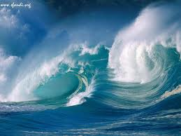](http://images.google.co.il/imgres?imgurl=http://www.canoaclubverona.it/images/foto/wallpaper/W-Onde.jpg&imgrefurl=http://georgiamada.splinder.com/post/4885348&usg=__aU2hVmtRssRqAPt3UWG7kPp1mzU=&h=768&w=1024&sz=89&hl=iw&start=38&tbnid=bfe8GVPTjPUPyM:&tbnh=113&tbnw=150&prev=/images?q=onde&start=20&gbv=2&ndsp=20&hl=iw&safe=vss&sa=N)

גַּל

|  |  |  |  |  |
| --- | --- | --- | --- | --- |
| דָּג | אַבָּא | גַּל | אִמָא | יָּם |
| יָּם | דַּיָּג | גַּל | יָּם | גַּל |
| גַּל | דַּיָּג | יָּם | גַּל | דָּג |
| אַבָּא | גַּל | גַּל | דַּיָּג | גַּל |
| דָּג | אִמָא | דַּיָּג | גַּל | גַּל |

דַּיָּג

C:\Documents and Settings\User\Local Settings\Temporary Internet Files\Content.IE5\ZGO3CI8F\MC900217192[1].wmfMCj03056770000[1]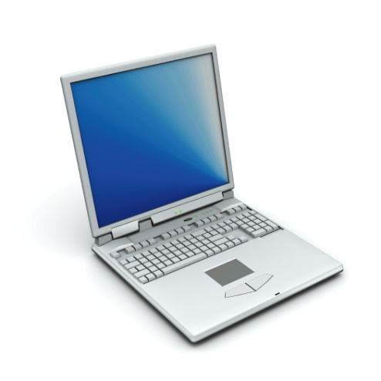

חַכָּה

C:\Documents and Settings\User\Local Settings\Temporary Internet Files\Content.IE5\KXK8FNFA\MC900290903[1].wmfC:\Documents and Settings\User\Local Settings\Temporary Internet Files\Content.IE5\OCXBEG80\MC900234186[1].wmfMCj03056770000[1]

C:\Documents and Settings\User\Local Settings\Temporary Internet Files\Content.IE5\AKH6B8CY\MC900353677[1].wmf

דַּ

ג

יָ

חַכָּה

MCj03056770000[1]

דַּיָּג

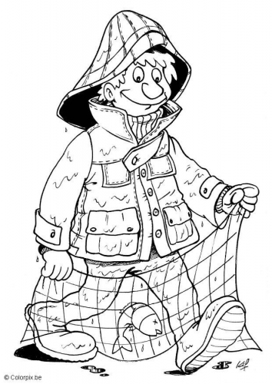

דָּג

[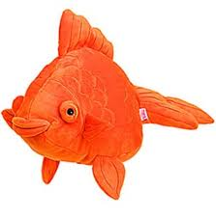](http://images.google.co.il/imgres?imgurl=http://www.copperstix.com/images/golf/goldfish.jpg&imgrefurl=http://www.copperstix.com/display_golf_head_covers/Original_Goldfish.asp&usg=__A7yyevQa5ci0hcZpJlEkkcYcAdw=&h=322&w=319&sz=33&hl=iw&start=19&tbnid=a4YQ95Hq1Uk-0M:&tbnh=118&tbnw=117&prev=/images?q=goldfish&gbv=2&hl=iw&safe=vss&sa=X)

גַּל

[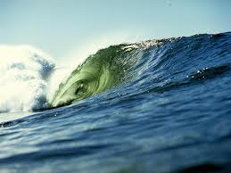](http://images.google.co.il/imgres?imgurl=http://www.bsh.co.il/images/ArticlesImages/%D7%92%D7%9C%20%D7%92%D7%93%D7%95%D7%9C.jpg&imgrefurl=http://www.bsh.co.il/ShowArticle2.asp?ArticleId=1157&usg=__NZpX5izcQyjupixZ5Q4ShIwS9HY=&h=600&w=800&sz=62&hl=iw&start=79&tbnid=RkT2a0V6t8ZDkM:&tbnh=107&tbnw=143&prev=/images?q=%D7%92%D7%9C&start=60&gbv=2&ndsp=20&hl=iw&safe=vss&sa=N)

זָהָב

[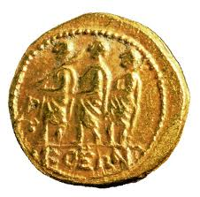](http://images.google.co.il/imgres?imgurl=http://giornale.regione.marche.it/archivio/num91098/foto17ag.jpg&imgrefurl=http://giornale.regione.marche.it/galleria/num91098/foto17a.htm&usg=__zQN1CIb7eEDxNUYzFAlR6Fs9eaE=&h=394&w=400&sz=113&hl=iw&start=6&tbnid=pd6f3B-56ADMuM:&tbnh=122&tbnw=124&prev=/images?q=oro+tesoro&gbv=2&hl=iw&safe=vss)

[](http://images.google.co.il/imgres?imgurl=http://giornale.regione.marche.it/archivio/num91098/foto17ag.jpg&imgrefurl=http://giornale.regione.marche.it/galleria/num91098/foto17a.htm&usg=__zQN1CIb7eEDxNUYzFAlR6Fs9eaE=&h=394&w=400&sz=113&hl=iw&start=6&tbnid=pd6f3B-56ADMuM:&tbnh=122&tbnw=124&prev=/images?q=oro+tesoro&gbv=2&hl=iw&safe=vss)

דָּג חַ

חַכָּה גַּ

דַּיָּג זָ

גַּל דָּ

זָהָב דַּ

[](http://images.google.co.il/imgres?imgurl=http://www.hardestam.se/page18/files/fisherman_1.jpg&imgrefurl=http://hardestam.blogspot.com/2007/10/fisherman.html&usg=__XcVNNCjB5S_IZT3yCWASz_CGbTo=&h=420&w=400&sz=63&hl=iw&start=14&sig2=DKn4X7RtTxiEIboC0jFRQw&tbnid=4DkSNVc2bAnIMM:&tbnh=125&tbnw=119&ei=VYmBSaToJI6g_gaXysTXDg&prev=/images?q=fisherman&gbv=2&hl=iw&safe=vss)זָהָב

[](http://images.google.co.il/imgres?imgurl=http://www.masa.co.il/_content/images/0111fb88eaf12f81b38b1a2d6a24dd9f_goldfish__amanda_rohde.jpg&imgrefurl=http://www.masa.co.il/article/806/%D7%93%D7%92-%D7%96%D7%94%D7%91:-%D7%9E%D7%9E%D7%94-%D7%94%D7%95%D7%90-%D7%A2%D7%A9%D7%95%D7%99&usg=__SA2tzkOi82JSWOFfV_6mb469WMA=&h=349&w=344&sz=113&hl=iw&start=101&tbnid=q0-rhmFVeMIYXM:&tbnh=120&tbnw=118&prev=/images?q=%D7%93%D7%92&start=100&gbv=2&ndsp=20&hl=iw&safe=vss&sa=N)חַכָּה

[](http://images.google.co.il/imgres?imgurl=http://www.usagold.com/images/gold-coins-images.jpeg&imgrefurl=http://www.usagold.com/amk/abcs-1000-savings.html&usg=__gZAzrfsR2_Fhb8kMFX6xjjhLERY=&h=300&w=300&sz=49&hl=iw&start=2&tbnid=hmlIpYP-qEvkeM:&tbnh=116&tbnw=116&prev=/images?q=gold&gbv=2&hl=iw&safe=vss&sa=G)גַּל

[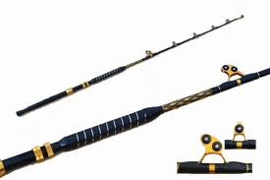](http://images.google.co.il/imgres?imgurl=http://www.buytacklenow.com/images/130lFGA.jpg&imgrefurl=http://www.fxp.co.il/showthread.php?t=2401219&usg=____gzZyQFWMgZjEA_jKUuBXwX_cs=&h=333&w=500&sz=23&hl=iw&start=46&tbnid=AZiPGETfg1pIBM:&tbnh=87&tbnw=130&prev=/images?q=%D7%97%D7%9B%D7%94&start=40&gbv=2&ndsp=20&hl=iw&safe=vss&sa=N)דָּג

[](http://images.google.co.il/imgres?imgurl=http://www.canoaclubverona.it/images/foto/wallpaper/W-Onde.jpg&imgrefurl=http://georgiamada.splinder.com/post/4885348&usg=__aU2hVmtRssRqAPt3UWG7kPp1mzU=&h=768&w=1024&sz=89&hl=iw&start=38&tbnid=bfe8GVPTjPUPyM:&tbnh=113&tbnw=150&prev=/images?q=onde&start=20&gbv=2&ndsp=20&hl=iw&safe=vss&sa=N)דַּיָּג

זָהָב

[](http://images.google.co.il/imgres?imgurl=http://www.monex.com/images/photos/prodGold01.jpg&imgrefurl=http://www.monex.com/prods/gold.html&usg=__oqRrTqhal7zVLuHL-73eLq5e73k=&h=301&w=365&sz=17&hl=iw&start=6&tbnid=DCxRAQrXXNkKIM:&tbnh=100&tbnw=121&prev=/images?q=gold&gbv=2&hl=iw&safe=vss&sa=G)MCj04283870000[1]

[](http://images.google.co.il/imgres?imgurl=http://www.frontiernet.net/~cgrafe/animations/frogchelle.gif&imgrefurl=http://www.frontiernet.net/~cgrafe/animationb.html&usg=__5i4daCBbuH0JXpps8kmdHllTcNQ=&h=207&w=236&sz=22&hl=iw&start=11&tbnid=3ah6JD7vQP3YnM:&tbnh=96&tbnw=109&prev=/images?q=cat+animation&gbv=2&hl=iw&safe=vss)

חַכָּה

[](http://images.google.co.il/imgres?imgurl=http://bluebuddies.com/gallery/Smurf_Animation_Cels/jpg/Smurfs_Animation_Cel_Azrael_Hypnotized.jpg&imgrefurl=http://bluebuddies.com/Smurfs_Smurf_Animation_Cels-43.htm&usg=__u9LBHykE8g7ihgl1IQFMLsfhCyA=&h=295&w=400&sz=18&hl=iw&start=55&tbnid=oBA_DbvznP25EM:&tbnh=91&tbnw=124&prev=/images?q=cat+animation&start=40&gbv=2&ndsp=20&hl=iw&safe=vss&sa=N)[](http://images.google.co.il/imgres?imgurl=http://school.discoveryeducation.com/clipart/images/k-bear.gif&imgrefurl=http://school.discoveryeducation.com/clipart/clip/k-bear.html&usg=__T9mOqAqrdlAN16QKAiXx6I3OrwE=&h=400&w=360&sz=6&hl=iw&start=691&um=1&tbnid=sS5VrvLlu5Ks9M:&tbnh=124&tbnw=112&prev=/images?q=bear&start=680&ndsp=20&um=1&hl=iw&safe=vss&sa=N)[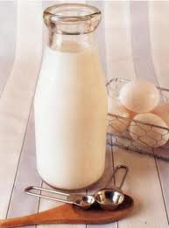](http://images.google.co.il/imgres?imgurl=http://www.boazvet.com/Images/Matkonim/Milk1.jpg&imgrefurl=http://www.boazvet.com/Articles/matkonim/Milk.aspx&usg=__1WOP6hwlHW_dvycDe0dgRyngYpI=&h=347&w=256&sz=12&hl=iw&start=136&tbnid=Y-GyduCZHsQuyM:&tbnh=120&tbnw=89&prev=/images?q=%D7%97%D7%9C%D7%91&start=120&gbv=2&ndsp=20&hl=iw&safe=vss&sa=N)[](http://images.google.co.il/imgres?imgurl=http://www.buytacklenow.com/images/130lFGA.jpg&imgrefurl=http://www.fxp.co.il/showthread.php?t=2401219&usg=____gzZyQFWMgZjEA_jKUuBXwX_cs=&h=333&w=500&sz=23&hl=iw&start=46&tbnid=AZiPGETfg1pIBM:&tbnh=87&tbnw=130&prev=/images?q=%D7%97%D7%9B%D7%94&start=40&gbv=2&ndsp=20&hl=iw&safe=vss&sa=N)

גַּל

[](http://images.google.co.il/imgres?imgurl=http://www.mkm-haifa.co.il/schools/hofit/lea/leah_goldberg/MCj04077800000%5B1%5D1.gif&imgrefurl=http://www.mkm-haifa.co.il/schools/hofit/lea/leah_goldberg/yeladim_bageshem.htm&usg=__0URki2ewJnPjZFnNtHGZDNbO6dc=&h=194&w=128&sz=3&hl=iw&start=18&tbnid=a4o7LkibCgITPM:&tbnh=103&tbnw=68&prev=/images?q=%D7%92%D7%9E%D7%93%D7%99%D7%9D&gbv=2&hl=iw&safe=vss)[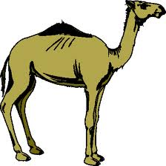](http://images.google.co.il/imgres?imgurl=http://www.wtsmith.com/giffiles/camel.gif&imgrefurl=http://www.wtsmith.com/songs/alice.html&usg=__AQmJoccvT4dq5qUbTNmCnpGYXLo=&h=401&w=400&sz=7&hl=iw&start=15&tbnid=WnQRmIFycLC7LM:&tbnh=124&tbnw=124&prev=/images?q=camel&gbv=2&hl=iw&safe=vss)

[](http://images.google.co.il/imgres?imgurl=http://www.mio.co.il/var/1293/113470-%D7%97%D7%A1%D7%99%D7%93%D7%94%203.jpg&imgrefurl=http://www.mio.co.il/aecommerce/c2825/16866.php&usg=__L_SEr_yvr7jw6_kKPlx3rD092ZE=&h=341&w=600&sz=25&hl=iw&start=16&tbnid=2uzIgZ4q_AJxRM:&tbnh=77&tbnw=135&prev=/images?q=%D7%97%D7%A1%D7%99%D7%93%D7%94&gbv=2&ndsp=20&hl=iw&safe=vss&sa=N)[](http://images.google.co.il/imgres?imgurl=http://www.canoaclubverona.it/images/foto/wallpaper/W-Onde.jpg&imgrefurl=http://georgiamada.splinder.com/post/4885348&usg=__aU2hVmtRssRqAPt3UWG7kPp1mzU=&h=768&w=1024&sz=89&hl=iw&start=38&tbnid=bfe8GVPTjPUPyM:&tbnh=113&tbnw=150&prev=/images?q=onde&start=20&gbv=2&ndsp=20&hl=iw&safe=vss&sa=N)

[](http://images.google.co.il/imgres?imgurl=http://www.gifs.net/Animation11/Hobbies_and_Entertainment/Fishing/Fisherman_4.gif&imgrefurl=http://www.gifs.net/image/Hobbies_and_Entertainment/Fishing/Fisherman_4/10282&usg=__e1RmcqNFKU0qfAAxHnFUrIYH8us=&h=168&w=150&sz=5&hl=iw&start=32&sig2=i7p5U3up2lp4xu-jMPl_mQ&tbnid=LtUB2APXCSok8M:&tbnh=99&tbnw=88&ei=z4uBSdjFHcec_gaaqIDaDg&prev=/images?q=fisherman+animation&start=20&gbv=2&ndsp=20&hl=iw&safe=vss&sa=N)[](http://images.google.co.il/imgres?imgurl=http://www.buytacklenow.com/images/130lFGA.jpg&imgrefurl=http://www.fxp.co.il/showthread.php?t=2401219&usg=____gzZyQFWMgZjEA_jKUuBXwX_cs=&h=333&w=500&sz=23&hl=iw&start=46&tbnid=AZiPGETfg1pIBM:&tbnh=87&tbnw=130&prev=/images?q=%D7%97%D7%9B%D7%94&start=40&gbv=2&ndsp=20&hl=iw&safe=vss&sa=N)

דָּג חַכָּה

גַּל דַּיָּג

זָהָב חַכָּה

גַּל יַלְדָה

זָהָב דַּיְסָה

גַּל קְעָרָה

מַלְכָּה חַכָּה

גַּל יַלְדָה

MCj04303980000[1]MCj04324450000[1]

זָהָב חַכָּה

גַּל יַלְדָה

דָּג חַכָּה

גַּל יַלְדָה

[](http://images.google.co.il/imgres?imgurl=http://giornale.regione.marche.it/archivio/num91098/foto17ag.jpg&imgrefurl=http://giornale.regione.marche.it/galleria/num91098/foto17a.htm&usg=__zQN1CIb7eEDxNUYzFAlR6Fs9eaE=&h=394&w=400&sz=113&hl=iw&start=6&tbnid=pd6f3B-56ADMuM:&tbnh=122&tbnw=124&prev=/images?q=oro+tesoro&gbv=2&hl=iw&safe=vss)[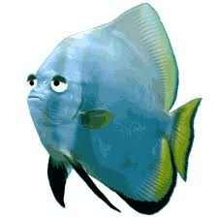](http://images.google.co.il/imgres?imgurl=http://www.leggievai.it/pesce-aprile/img/pesce.gif&imgrefurl=http://www.leggievai.it/pesce-aprile/leggende-pesce-aprile.php&usg=__057p2KKktGiMDH_dFl_IRiQhaZw=&h=300&w=300&sz=14&hl=iw&start=3&tbnid=nqqRw_-EVn2nkM:&tbnh=116&tbnw=116&prev=/images?q=pesce&gbv=2&hl=iw&safe=vss)

זָהָב חַכָּה

יַעַר יַלְדָה

זָהָב צַיָּד

גַּל יַלְדָה

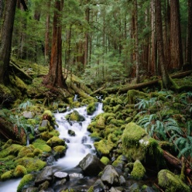MCj02400570000[1]

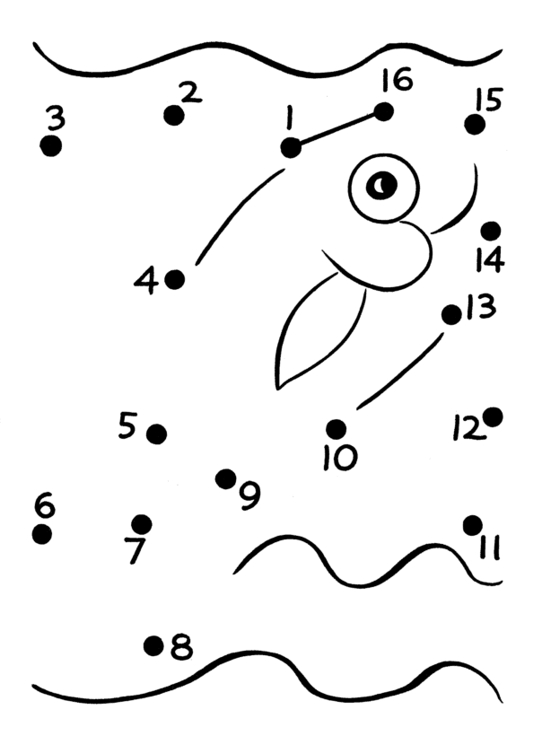

|  |  |  |  |  |  |  |
| --- | --- | --- | --- | --- | --- | --- |
| גַּ |  | חַ |  | יָ |  | דָּ |
| ל |  | כָּה |  | ם |  | ג |

|  |  |  |  |  |  |  |
| --- | --- | --- | --- | --- | --- | --- |
| זָ |  | יַלְ |  | יַ |  | דַּיְ |
| הָב |  | דָה |  | עַר |  | סָה |

[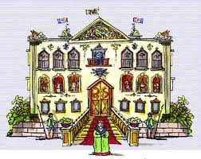](http://images.google.co.il/imgres?imgurl=http://www.li-net.net/nodewebimages/16346/palace1.gif&imgrefurl=http://www.li-net.net/nodeweb.asp?t=16346&subid=9421&usg=__1qeccNop9eOU9SctMgi4HaZxI34=&h=355&w=447&sz=88&hl=iw&start=77&tbnid=UQPHz8lvExhNuM:&tbnh=101&tbnw=127&prev=/images?q=%D7%90%D7%A8%D7%9E%D7%95%D7%9F&start=60&gbv=2&ndsp=20&hl=iw&safe=vss&sa=N)[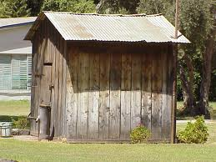](http://images.google.co.il/imgres?imgurl=http://www.photolight.co.il/photo/2008-01-29/158501.jpg&imgrefurl=http://www.photolight.co.il/show_photo/author6702/158501.html&usg=__422LCZjP807l6LVZwFaVzAldwWg=&h=480&w=640&sz=88&hl=iw&start=18&tbnid=p3GeSZGfENe5cM:&tbnh=103&tbnw=137&prev=/images?q=%D7%A6%D7%A8%D7%99%D7%A3&gbv=2&hl=iw&safe=vss)

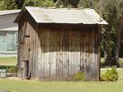

[](http://images.google.co.il/imgres?imgurl=https://payperpost.com/opportunities/images/3723/image2.jpg&imgrefurl=http://www.shatteredsun.net/2007/01/&usg=__j77fMxw_caq4j7-cxn6b_UOwif8=&h=175&w=124&sz=29&hl=iw&start=9&tbnid=4MH2lqPzXibqgM:&tbnh=100&tbnw=71&prev=/images?q=doll+palace&gbv=2&ndsp=20&hl=iw&safe=vss&sa=N)[](http://images.google.co.il/imgres?imgurl=http://upload.wikimedia.org/wikipedia/commons/d/d9/Old_farmer_woman.JPG&imgrefurl=http://commons.wikimedia.org/wiki/File:Old_farmer_woman.JPG&usg=__4yhF5z0pwc4deg1FTRxkRfHgW9k=&h=1352&w=901&sz=165&hl=iw&start=1&tbnid=fXpw_YA3bpriKM:&tbnh=150&tbnw=100&prev=/images?q=farmer+woman&gbv=2&hl=iw&safe=vss)

1

2

3

*MCj04133120000[1]*MCj03264920000[1]

*flag2*

MCj03306230000[1]

[](http://images.google.com/imgres?imgurl=http://www.pcon.co.il/data/images/hed_rej/072105_fish_depression.gif&imgrefurl=http://www.pcon.co.il/v5/ChosenPikantItem.asp?id0=777&h=177&w=190&sz=9&hl=iw&start=3&tbnid=7qCR7tOHij0n9M:&tbnh=96&tbnw=103&prev=/images?q=%D7%93%D7%92&gbv=2&svnum=10&hl=iw&sa=G)

[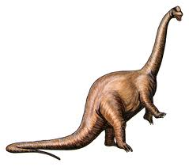](http://images.google.com/imgres?imgurl=http://www.talpiot.macam98.ac.il/actual/jafa/jaf/main/dino/apato.gif&imgrefurl=http://www.talpiot.macam98.ac.il/actual/jafa/jaf/main/dino/dinomain.htm&h=413&w=468&sz=43&hl=iw&start=170&tbnid=QoLziS1dgC0deM:&tbnh=113&tbnw=128&prev=/images?q=%D7%93%D7%99%D7%A0%D7%95%D7%96%D7%90%D7%95%D7%A8&start=160&gbv=2&ndsp=20&svnum=10&hl=iw&sa=N)

MCj01113660000[1]

*MCj03561050000[1]*

[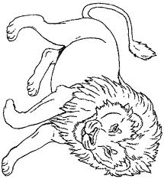](http://images.google.co.il/imgres?imgurl=http://www.janbrett.com/images/mural_hhl_lion.jpg&imgrefurl=http://www.janbrett.com/mural_hhl/mural_hhl_lion.htm&usg=__2AgO9dCuSslLdJ5WWxFxdw7_6WE=&h=698&w=640&sz=205&hl=iw&start=39&tbnid=M-WjtiSrI8uWMM:&tbnh=139&tbnw=127&prev=/images?q=lion%5D&start=20&gbv=2&ndsp=20&hl=iw&safe=vss&sa=N)[](http://images.google.co.il/imgres?imgurl=http://by1.storage.msn.com/y1pJh2_WRz-_aXaLFfRURaNG-x4gGkc2uEQjNO-0yivO9t2n-z4DuXQO7x09cTKdEM_Om5T7l3KWqgMVY6pevMORIVg-iJRoqSE?PARTNER=WRITER&imgrefurl=http://vallisidney.spaces.live.com/blog/cns!DE737D4E73A5D48B!740.entry&usg=__s-rEqS5h85MaisiCIkdrByGD5PY=&h=227&w=244&sz=19&hl=iw&start=26&tbnid=1N7FlaLrOp2IPM:&tbnh=102&tbnw=110&prev=/images?q=biancaneve+nano&start=20&gbv=2&ndsp=20&hl=iw&safe=vss&sa=N)*MCj04133120000[1]*

[](http://images.google.co.il/imgres?imgurl=http://www.whatonemillionbuys.com/wp-content/uploads/2008/05/ice-cream.jpg&imgrefurl=http://www.whatonemillionbuys.com/tag/lazare-kaplan-international-inc&usg=__S3Rwx1egjg7uc6TZ_LlrE_m5VqE=&h=373&w=539&sz=43&hl=iw&start=1&tbnid=3Om-sIqs2TQwwM:&tbnh=91&tbnw=132&prev=/images?q=ice+cream&gbv=2&hl=iw&safe=vss&sa=X)

MCj03306230000[1]

*[](http://images.google.com/imgres?imgurl=http://www.pcon.co.il/data/images/hed_rej/072105_fish_depression.gif&imgrefurl=http://www.pcon.co.il/v5/ChosenPikantItem.asp?id0=777&h=177&w=190&sz=9&hl=iw&start=3&tbnid=7qCR7tOHij0n9M:&tbnh=96&tbnw=103&prev=/images?q=%D7%93%D7%92&gbv=2&svnum=10&hl=iw&sa=G)*[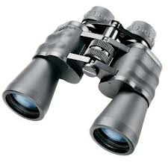](http://images.google.co.il/imgres?imgurl=http://www.hagorshops.co.il/var/1767/185806-%D7%9E%D7%A9%D7%A7%D7%A4%D7%AA%20%D7%96%D7%95%D7%9D.jpg&imgrefurl=http://www.hagorshops.co.il/aecommerce/c4498/22004.php&usg=__rig1sZdnogN4D2aMBBJYo3bLwiE=&h=400&w=400&sz=20&hl=iw&start=6&tbnid=daykIsAy7JL8LM:&tbnh=124&tbnw=124&prev=/images?q=%D7%9E%D7%A9%D7%A7%D7%A4%D7%AA&gbv=2&hl=iw&safe=vss)

[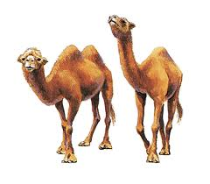](http://images.google.co.il/imgres?imgurl=http://static.howstuffworks.com/gif/willow/camel-info0.gif&imgrefurl=http://animals.howstuffworks.com/mammals/camel-info.htm&usg=__u5LTYMCfbxr4lu3mbIIR0r6BhEQ=&h=300&w=343&sz=36&hl=iw&start=3&tbnid=DVU4Kcxm7kwWVM:&tbnh=105&tbnw=120&prev=/images?q=camel&gbv=2&hl=iw&safe=vss)

יָם

[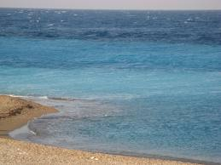](http://images.google.co.il/imgres?imgurl=http://things.co.il/wp-content/gallery/Rhodes/Beautiful-Sea.jpg&imgrefurl=http://things.co.il/photos/greece/rhodes-2007?pid=1571&usg=__2f9gLyEzgRyNBt6FCW9Xe3_LdBo=&h=768&w=1024&sz=384&hl=iw&start=1&tbnid=3fxTlXql768aYM:&tbnh=113&tbnw=150&prev=/images?q=sea&gbv=2&hl=iw&safe=vss)

יָם

[](http://images.google.co.il/imgres?imgurl=http://things.co.il/wp-content/gallery/Rhodes/Beautiful-Sea.jpg&imgrefurl=http://things.co.il/photos/greece/rhodes-2007?pid=1571&usg=__2f9gLyEzgRyNBt6FCW9Xe3_LdBo=&h=768&w=1024&sz=384&hl=iw&start=1&tbnid=3fxTlXql768aYM:&tbnh=113&tbnw=150&prev=/images?q=sea&gbv=2&hl=iw&safe=vss)

[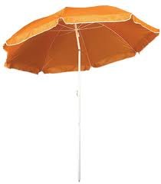](http://images.google.co.il/imgres?imgurl=http://www.ronitlevy.co.il/var/736/17529-TX1100open.jpg&imgrefurl=http://www.ronitlevy.co.il/apage/2755.php&usg=__ygwgJkJZ_0J7dweNdyK3s3P8zes=&h=709&w=621&sz=117&hl=iw&start=58&tbnid=Zp02kfR2pkoDMM:&tbnh=140&tbnw=123&prev=/images?q=%D7%A9%D7%9E%D7%A9%D7%99%D7%94&start=40&gbv=2&ndsp=20&hl=iw&safe=vss&sa=N)[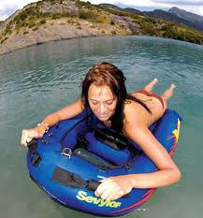](http://images.google.co.il/imgres?imgurl=http://www.seaspeed.co.il/images/stories/sevylor/Reef55Action.jpg&imgrefurl=http://www.seaspeed.co.il/sevylor/REEF55.htm&usg=__DHjM-tS7u0wdYg0_qXiUYUkp528=&h=350&w=326&sz=39&hl=iw&start=54&tbnid=I-j8BXVQ09x4YM:&tbnh=120&tbnw=112&prev=/images?q=%D7%92%D7%9C%D7%A9%D7%9F&start=40&gbv=2&ndsp=20&hl=iw&safe=vss&sa=N)[](http://images.google.co.il/imgres?imgurl=http://www.orianit.edu-negev.gov.il/irisbnto/sites/homepage/moreshet/Images/%D7%A2%D7%A5.gif&imgrefurl=http://www.orianit.edu-negev.gov.il/irisbnto/sites/homepage/moreshet/allmuo.htm&usg=__jvqfR9ksAlGTkThgMpff6dBSu80=&h=967&w=1042&sz=77&hl=iw&start=27&tbnid=xob1lWNT8XSgNM:&tbnh=139&tbnw=150&prev=/images?q=%D7%A2%D7%A5&start=20&gbv=2&ndsp=20&hl=iw&safe=vss&sa=N)[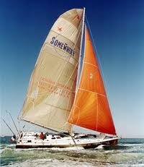](http://images.google.co.il/imgres?imgurl=http://www.epochtimes.co.il/news/images/stories/2007d3/consume/mifrasit-b.jpg&imgrefurl=http://www.epochtimes.co.il/news/content/view/8066/123/&usg=__ZleQ7uAgZ5dcOYs_oyCaO4jKcs8=&h=289&w=250&sz=25&hl=iw&start=13&tbnid=MwB-Meezyn5h_M:&tbnh=115&tbnw=99&prev=/images?q=%D7%9E%D7%A4%D7%A8%D7%A9%D7%99%D7%AA&gbv=2&hl=iw&safe=vss&sa=G)[](http://images.google.co.il/imgres?imgurl=http://rg.ramat-gan.info/NR/rdonlyres/64A77829-FE67-4AA9-9CEE-0E04C6BDE025/0/%D7%93%D7%95%D7%9C%D7%A4%D7%99%D7%9F.jpg&imgrefurl=http://www.ramat-gan.info/gan/74/%D7%A0%D7%90+%D7%9C%D7%94%D7%9B%D7%99%D7%A8.htm&usg=__WENJnhAkqToWtoJmKWJ4_61bG_c=&h=256&w=256&sz=19&hl=iw&start=5&tbnid=lqXSP7k_LzvTnM:&tbnh=111&tbnw=111&prev=/images?q=%D7%93%D7%95%D7%9C%D7%A4%D7%99%D7%9F&gbv=2&hl=iw&safe=vss)

[http://tbn1.google.com/images?q=tbn:42ZJeWxg7HsrBM:http://www.seaspeed.co.il/images/stories/aquascooter/aquascooter_kayak_main.jpg](http://images.google.co.il/imgres?imgurl=http://www.seaspeed.co.il/images/stories/aquascooter/aquascooter_kayak_main.jpg&imgrefurl=http://www.seaspeed.co.il/engines/aqua-scooter/aquascooter_kayak.html&usg=__wwlOIGFFrSP9_T8wiCODoURprBs=&h=320&w=750&sz=28&hl=iw&start=103&tbnid=42ZJeWxg7HsrBM:&tbnh=60&tbnw=141&prev=/images?q=%D7%92%D7%9C%D7%A9%D7%9F&start=100&gbv=2&ndsp=20&hl=iw&safe=vss&sa=N)[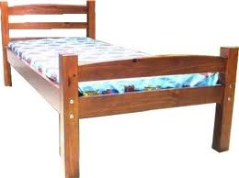](http://images.google.co.il/imgres?imgurl=http://www.konim1.co.il/pictures/20/511136.jpg&imgrefurl=http://www.konim1.co.il/prodetailsamewin.asp?pro_id=48&usg=__BKm1S5LYXsv4MA76YOjsphaS-Bc=&h=296&w=396&sz=22&hl=iw&start=19&tbnid=yJTtH360M9hp5M:&tbnh=93&tbnw=124&prev=/images?q=%D7%9E%D7%99%D7%98%D7%94&gbv=2&hl=iw&safe=vss)[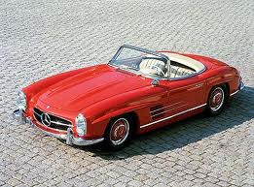](http://images.google.co.il/imgres?imgurl=http://www.ynet.co.il/PicServer2/04062007/1332327/merc_wa.jpg&imgrefurl=http://www.ynet.co.il/Ext/Comp/ArticleLayout/CdaArticlePrintPreview/1,2506,L-3591504,00.html&usg=__8J5h_rNksp9H1Y3roAkthQFDERg=&h=303&w=408&sz=42&hl=iw&start=49&tbnid=F-ltd9qs4OVB1M:&tbnh=93&tbnw=125&prev=/images?q=%D7%9E%D7%9B%D7%95%D7%A0%D7%99%D7%95%D7%AA&start=40&gbv=2&ndsp=20&hl=iw&safe=vss&sa=N)[](http://images.google.co.il/imgres?imgurl=http://www.pelu-art.com/images/catalog/big_whale-b.jpg&imgrefurl=http://www.pelu-art.com/hebrew/catalog_bigPic.asp?prod=97&usg=__BerIn1wra_VCgpSiSrW9wpa2z88=&h=166&w=220&sz=6&hl=iw&start=161&tbnid=0UDXiZt4-XFlwM:&tbnh=81&tbnw=107&prev=/images?q=%D7%9C%D7%95%D7%99%D7%AA%D7%9F&start=160&gbv=2&ndsp=20&hl=iw&safe=vss&sa=N)

MCj03914620000[1]

|  |  |  |  |  |  |
| --- | --- | --- | --- | --- | --- |
| מַ | לְ | כָּה | גַּ | יַ | יַ |
| גַּ | מָּ | ד | ל | לְ | עַ |
| יָ | זָ | הָ | ב | דָה | ר |
| ם | דַּ | יְ | סָה | חַ | כָּה |
| קְ | עָ | רָה | צַ | יָּ | ד |

חַכָּה, זָהָב, מַלְכָּה, גַּל, זָהָב, צַיָּד,

יַלְדָה, קְעָרָה, יָם , דַּיְסָה, גַּמָּד

[](http://images.google.co.il/imgres?imgurl=http://www.buytacklenow.com/images/130lFGA.jpg&imgrefurl=http://www.fxp.co.il/showthread.php?t=2401219&usg=____gzZyQFWMgZjEA_jKUuBXwX_cs=&h=333&w=500&sz=23&hl=iw&start=46&tbnid=AZiPGETfg1pIBM:&tbnh=87&tbnw=130&prev=/images?q=%D7%97%D7%9B%D7%94&start=40&gbv=2&ndsp=20&hl=iw&safe=vss&sa=N)[](http://images.google.co.il/imgres?imgurl=http://www.hardestam.se/page18/files/fisherman_1.jpg&imgrefurl=http://hardestam.blogspot.com/2007/10/fisherman.html&usg=__XcVNNCjB5S_IZT3yCWASz_CGbTo=&h=420&w=400&sz=63&hl=iw&start=14&sig2=DKn4X7RtTxiEIboC0jFRQw&tbnid=4DkSNVc2bAnIMM:&tbnh=125&tbnw=119&ei=VYmBSaToJI6g_gaXysTXDg&prev=/images?q=fisherman&gbv=2&hl=iw&safe=vss)

[](http://images.google.co.il/imgres?imgurl=http://childstoryhour.com/images/coloring/fish.jpg&imgrefurl=http://www.kesem.biz/Article.aspx?ID=197&usg=__nuW-nepNgibadjMW2GeuiSK0mRU=&h=539&w=900&sz=79&hl=iw&start=118&tbnid=lunPV_sg1dZ2SM:&tbnh=87&tbnw=146&prev=/images?q=%D7%93%D7%92&start=100&gbv=2&ndsp=20&hl=iw&safe=vss&sa=N)

דָּג זָהָב

צַיָּד

דָּג זָהָב

גַּמָּד

יַלְדָה