[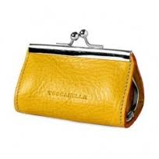](http://www.google.co.il/url?sa=i&source=images&cd=&cad=rja&docid=-laE2dPdlLs46M&tbnid=0T4gf-yzxafZVM:&ved=0CAgQjRw4Dg&url=http://www.solomarket.co.il/product_cat_23_701.html&ei=4jblUuzFG8iV0AX42YDIDg&psig=AFQjCNE6muDNzdTgMFl2uDxSXVCD9XxfDQ&ust=1390839906840393)

MCj01093550000[1]

# אָ

MCAN00223_0000[1]

MCj03568930000[1]

[](http://www.google.co.il/url?sa=i&source=images&cd=&cad=rja&docid=EUEnSlDyJupBEM&tbnid=DeySlI1dqi-5CM:&ved=0CAgQjRw&url=http://cafe.themarker.com/image/1860412/&ei=WDblUurGKcHb0QX6wIHACA&psig=AFQjCNFCGFCjunLQCXbkrt-UlSXmIMAFQg&ust=1390839768763794)

j0350389



# בָּ



MCAN00290_0000[1]



MCj04246860000[1]MCj04107710000[1]

# גָּ





MCj02381030000[1]



# דָּ

[](http://www.google.co.il/url?sa=i&rct=j&q=&esrc=s&frm=1&source=images&cd=&cad=rja&docid=qbd4xxPVa3mo3M&tbnid=90Czio4k3-UUCM:&ved=0CAUQjRw&url=http://www.istockphoto.com/stock-illustration-9991577-happy-postman-delivering-mail.php&ei=Sl8wUZOkJY-Mswbrq4CwDQ&psig=AFQjCNEbj5oF83d1H0yJ8jvOqED8zhxRCQ&ust=1362211016612554)

[](http://images.google.co.il/imgres?imgurl=http://www.sane-way.com/image/users/3139/detail/big/17412.jpg&imgrefurl=http://www.sane-way.com/site/detail/detail/detailDetail.asp?detail_id=17412&h=300&w=400&sz=15&hl=iw&start=1&sig2=Uq7nxNkrolG0imsDnttaLg&um=1&usg=__zb6Dtp8HZKqI7Tj-CsMtymb4FkI=&tbnid=jeHGAM1NnE0b4M:&tbnh=93&tbnw=124&ei=_THRSMqyEI6WwQGyyZkW&prev=/images?q=%D7%93%D7%92&um=1&hl=iw&rlz=1G1GGLQ_IWXX251&sa=N)

[](http://www.google.co.il/url?sa=i&rct=j&q=&esrc=s&frm=1&source=images&cd=&cad=rja&docid=ooNCaPrg0lbJXM&tbnid=aDGImO7Dn-6QhM:&ved=0CAUQjRw&url=http://bioweb.uwlax.edu/bio203/s2007/barger_rach/other_facts.htm&ei=fb6cUcmRJIid0QWbvIGACQ&psig=AFQjCNEdJbtU7aNtwHbiFA_LRrJSrsiHWw&ust=1369313268607417)

[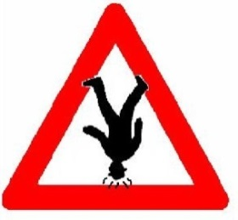](http://www.google.co.il/url?sa=i&rct=j&q=&esrc=s&frm=1&source=images&cd=&cad=rja&docid=OsJBPf5Ml2ET0M&tbnid=2NO_KE3Z-lHRcM:&ved=0CAUQjRw&url=http://www.tapuz.co.il/blog/tags.asp?tagname=%E4%F4%E5%EA+%F2%EC+%E4%F4%E5%EA&ei=pF43UYqSEpC00QXGqIHACA&psig=AFQjCNG7rGXwgSSH3tPr27o6-rSwr1wE_Q&ust=1362669574385849)[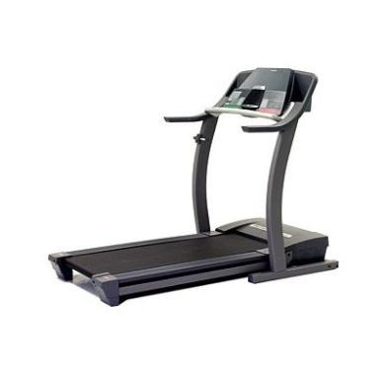](http://www.google.co.il/url?sa=i&rct=j&q=&esrc=s&frm=1&source=images&cd=&cad=rja&docid=KAAu99WFDdDfoM&tbnid=KSWupS67sKAYmM:&ved=0CAUQjRw&url=http://www.lifeisgood.co.il/article/200/&ei=8l43Ubq4KoSp0AW28YGICA&psig=AFQjCNGvAdZbsclXwad0cdUSiTRyDwDFfg&ust=1362669668889815)

הָ

[](http://www.google.co.il/url?sa=i&rct=j&q=&esrc=s&frm=1&source=images&cd=&cad=rja&docid=nZYBwozpqdG4bM&tbnid=3yS4Qycr1-WWqM:&ved=0CAUQjRw&url=http://www.iconarchive.com/show/food-icons-by-aha-soft/hamburger-icon.html&ei=ml83UZfNEOrH0QWBr4D4Bw&psig=AFQjCNHANFGwZOi9aZwYG4QPCQyzUPbAaw&ust=1362669795175861)[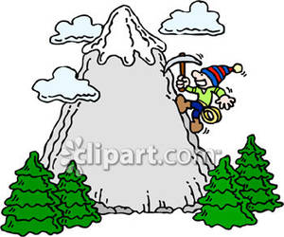](http://www.google.co.il/url?sa=i&rct=j&q=&esrc=s&frm=1&source=images&cd=&cad=rja&docid=G3YvFsKP4GYXiM&tbnid=jC2tK8tMUS66ZM:&ved=0CAUQjRw&url=http://www.picturesof.net/pages/090302-210833-235042.html&ei=-103Ucj4KImy0QXfxIH4CA&psig=AFQjCNH8dQMKB5KHv-UOLUXTGGaM2OREzg&ust=1362669413853071)

C:\Documents and Settings\User\Local Settings\Temporary Internet Files\Content.IE5\ZO87DVZM\MC900359149[1].wmfj0237615j0312174

חָ

*MCj04284030000[1]*

j0305299

[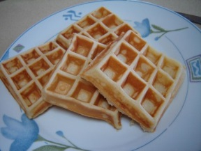](http://www.google.co.il/url?sa=i&rct=j&q=&esrc=s&frm=1&source=images&cd=&cad=rja&docid=i9uR5RUhUW5fcM&tbnid=VW-MqRXuL6jigM:&ved=0CAUQjRw&url=http://mayasfood.blogspot.com/2010/11/blog-post_03.html&ei=fEcwUevACcrNswa_rYGoAg&psig=AFQjCNHp2_IfOch1GUday7yUpvDTiXSMVg&ust=1362204907205880)[](http://www.google.co.il/url?sa=i&rct=j&q=&esrc=s&frm=1&source=images&cd=&cad=rja&docid=ooNCaPrg0lbJXM&tbnid=aDGImO7Dn-6QhM:&ved=0CAUQjRw&url=http://bioweb.uwlax.edu/bio203/s2007/barger_rach/other_facts.htm&ei=fb6cUcmRJIid0QWbvIGACQ&psig=AFQjCNEdJbtU7aNtwHbiFA_LRrJSrsiHWw&ust=1369313268607417)

וָ

C:\Documents and Settings\User\Local Settings\Temporary Internet Files\Content.IE5\7SBA55HE\MC900252343[1].wmfC:\Documents and Settings\User\Local Settings\Temporary Internet Files\Content.IE5\7SBA55HE\MC900434575[1].wmf

MCj02516970000[1]

טָ

MCj02972170000[1][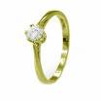](http://images.google.com/imgres?imgurl=http://www.p1000.co.il/hot_sale_product/21986.jpg&imgrefurl=http://www.p1000.co.il/hot_sale_bazaq_list.asp&h=200&w=200&sz=9&hl=iw&sig2=nHWkKbw-lBD2qjsf7bpl4g&start=4&tbnid=7W8dYIoRkhLrDM:&tbnh=104&tbnw=104&ei=czZ0RYqiE8vUwgGy_dzuDg&prev=/images?q=%D7%98%D7%91%D7%A2%D7%AA&svnum=10&hl=iw&lr=&sa=G)MCj02031200000[1]

[](http://images.google.com/imgres?imgurl=http://www.pcon.co.il/data/images/hed_rej/072105_fish_depression.gif&imgrefurl=http://www.pcon.co.il/v5/ChosenPikantItem.asp?id0=777&h=177&w=190&sz=9&hl=iw&start=3&tbnid=7qCR7tOHij0n9M:&tbnh=96&tbnw=103&prev=/images?q=%D7%93%D7%92&gbv=2&svnum=10&hl=iw&sa=G)C:\Documents and Settings\User\Local Settings\Temporary Internet Files\Content.IE5\7SBA55HE\MC900434575[1].wmf

C:\Documents and Settings\User\Local Settings\Temporary Internet Files\Content.IE5\BFOV3DZT\MC900350368[1].wmf

C:\Documents and Settings\User\Local Settings\Temporary Internet Files\Content.IE5\HSCVHM9A\MC900193506[1].wmf

זָ

MCj01092710000[1]MCAN00610_0000[1]C:\Documents and Settings\User\Local Settings\Temporary Internet Files\Content.IE5\XSGV0JTV\MC900312516[1].wmf

יָ

MCj04246860000[1]

MCj04106750000[1]



C:\Documents and Settings\User\Local Settings\Temporary Internet Files\Content.IE5\R0JMC0H0\MC900186120[1].wmfC:\Documents and Settings\purit1\Local Settings\Temporary Internet Files\Content.IE5\4R8RYL4Z\MCj02942180000[1].wmf

כָּ

[](http://www.google.co.il/imgres?imgurl=http://www.orianit.edu-negev.gov.il/yaelavnu/cp/homepage/Images/%D7%9B%D7%9C%D7%A0%D7%99%D7%AA.gif&imgrefurl=http://www.orianit.edu-negev.gov.il/yaelavnu/cp/homepage\105.htm&usg=__6snpi777EZ0YKbVzNO_D6gQ5oZk=&h=591&w=305&sz=20&hl=iw&start=52&zoom=1&itbs=1&tbnid=FCgsNbXiMim-1M:&tbnh=135&tbnw=70&prev=/images?q=%D7%9B%D7%9C%D7%A0%D7%99%D7%AA&start=40&hl=iw&sa=N&gbv=2&ndsp=20&tbs=isch:1)C:\Documents and Settings\purit1\Local Settings\Temporary Internet Files\Content.IE5\4R8RYL4Z\MCj03615400000[1].wmfC:\Documents and Settings\User\Local Settings\Temporary Internet Files\Content.IE5\ZO87DVZM\MC900359149[1].wmf

j0234186

C:\Documents and Settings\User\Local Settings\Temporary Internet Files\Content.IE5\9ZPOD99B\MC900129636[1].wmf

מָ

j0183478

C:\Documents and Settings\purit1\Local Settings\Temporary Internet Files\Content.IE5\0RW7MS0Q\MCj04355840000[1].wmf[](http://www.google.co.il/url?sa=i&rct=j&q=&esrc=s&frm=1&source=images&cd=&cad=rja&docid=Sty2UaqGrOf77M&tbnid=ZcGp-eNg55bJzM:&ved=0CAUQjRw&url=http://blog.spoongraphics.co.uk/tutorials/create-a-rolling-stones-inspired-tongue-illustration&ei=BN-cUemZN8PM0QXvoYGoDA&psig=AFQjCNHBtHO03vfoIFMGXMPw9UZVq-sI8w&ust=1369321588668230)

לָ

[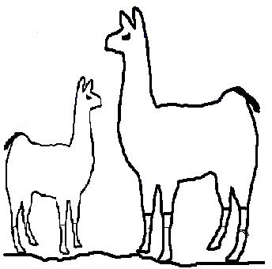](http://www.google.co.il/url?sa=i&rct=j&q=&esrc=s&frm=1&source=images&cd=&cad=rja&docid=u8X8Vf2kVBvvLM&tbnid=k2ODxpGWJ-Sn1M:&ved=0CAUQjRw&url=http://cafe.themarker.com/post/1890898/&ei=G9ucUcjYNciG0AWRxoDADg&psig=AFQjCNFZ5BTQ8OYJupc7Hgeyv8bKRuQpnw&ust=1369320516796943)[](http://www.google.co.il/imgres?imgurl=http://pascalpr.co.il/wp-content/uploads/2009/09/bread_new_year145e1.jpg&imgrefurl=http://www.pascalpr.co.il/?cat=19&usg=__smuNf_I-n1LJ7rp2c6fvJlQplNU=&h=145&w=145&sz=45&hl=iw&start=17&sig2=7SmYzWpymYKjndBEThVFww&zoom=1&itbs=1&tbnid=e0OX67JnujXl-M:&tbnh=95&tbnw=95&prev=/images?q=%D7%9C%D7%97%D7%9E%D7%A0%D7%99%D7%99%D7%94&hl=iw&gbv=2&tbs=isch:1&ei=TvOtTN7YC8KJ4QbW6LjTBg)C:\Documents and Settings\User\Local Settings\Temporary Internet Files\Content.IE5\J1X0H1D4\MC900371078[1].wmf

j0330623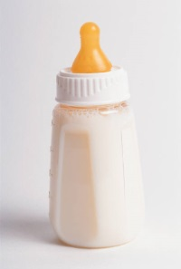

נָ

MCj02905790000[1]j0155643%5b1%5d

**j0332364**

MCj03559130000[1]

פָּ

j0350389j0215331

j0290774j0233666

j0198939

סָ

j0290435j0215172

[](http://www.google.co.il/url?sa=i&rct=j&q=&esrc=s&frm=1&source=images&cd=&cad=rja&docid=A3kmWd5xgnt4KM&tbnid=fIBfJiS4WPle5M:&ved=0CAUQjRw&url=http://depositphotos.com/2831138/stock-illustration-Artist-painting-at-the-easel.html&ei=0SadUZaVIIGEtAbFgYGgBg&psig=AFQjCNG-AB42-UZkzKWhx_SdZKdnshs3UA&ust=1369339824445090)[](http://www.google.co.il/url?sa=i&rct=j&q=&esrc=s&frm=1&source=images&cd=&cad=rja&docid=YJDsBsFZgCbM6M&tbnid=hEqX_99oV1iahM:&ved=0CAUQjRw&url=http://depositphotos.com/6038085/stock-illustration-Turtle-cartoon.html&ei=EiedUZjLNsGRtAasp4HIBg&psig=AFQjCNF7ERRU2i8WzYbnx8bHslx1zujOpQ&ust=1369340039649774)[](http://www.google.co.il/url?sa=i&rct=j&q=&esrc=s&frm=1&source=images&cd=&cad=rja&docid=Nnwf9mG1up3zoM&tbnid=FcyOUS_4sTsEXM:&ved=0CAUQjRw&url=http://www.istockphoto.com/stock-illustration-17612705-cartoon-painter.php&ei=giadUcfeE8aEtAaA3IGQBw&psig=AFQjCNG-AB42-UZkzKWhx_SdZKdnshs3UA&ust=1369339824445090)

צָ

j0185784[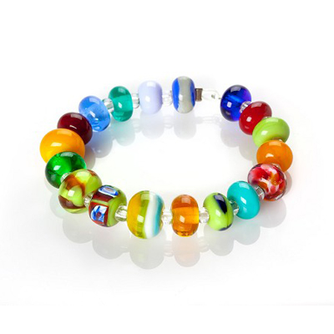](http://www.google.co.il/url?sa=i&rct=j&q=&esrc=s&frm=1&source=images&cd=&cad=rja&docid=JZ_kbI6OKz5lQM&tbnid=VggkGVSgLfIKQM:&ved=0CAUQjRw&url=http://www.u-boutique.co.il/Chapter-288-339-62-192.html&ei=NCWdUeAvguyzBrGJgJAH&psig=AFQjCNGH8siwysOtCF4-QuS1xvrB5LTwNw&ust=1369339558959844)MCj04241300000[1]

[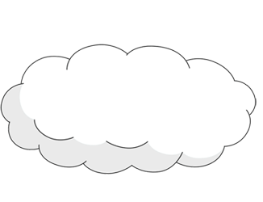](http://www.google.co.il/url?sa=i&rct=j&q=&esrc=s&frm=1&source=images&cd=&cad=rja&docid=2So_hLof1wWKtM&tbnid=ociOFqVzKe6iQM:&ved=0CAUQjRw&url=http://www.how-to-draw-cartoons-online.com/cartoon-clouds.html&ei=XumcUemNB6ez0QX0-4DwDw&psig=AFQjCNETtKi2ErfjH3MkJfmGFJiyYFgV7Q&ust=1369324237563155)[](http://www.google.co.il/url?sa=i&rct=j&q=&esrc=s&frm=1&source=images&cd=&cad=rja&docid=H5zuMGcV2rFNCM&tbnid=5jw6MZ5JFw9USM:&ved=0CAUQjRw&url=http://www.how-to-draw-cartoons-online.com/cartoon-mouse.html&ei=HOmcUerGNIWR0AXqyYDICw&psig=AFQjCNEWP0B1d-uY0NqwXIRs-jNe_sfyYA&ust=1369324184844462)MCj03914580000[1]

עָ

[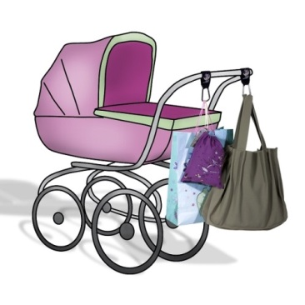](http://www.google.co.il/url?sa=i&rct=j&q=&esrc=s&frm=1&source=images&cd=&cad=rja&docid=wznvDPBroj9_YM&tbnid=ZKsopfLFg-08JM:&ved=0CAUQjRw&url=http://www.agalease-baby.co.il/?p=2042&ei=4iidUeyfN8SbtAbWgoG4Bw&psig=AFQjCNFI3W_ipJ8bViUzgeeBZ0pocTs5Vw&ust=1369340442528289)[](http://www.google.co.il/url?sa=i&rct=j&q=&esrc=s&frm=1&source=images&cd=&cad=rja&docid=VVgvMP9u5zNjNM&tbnid=OceJpIVqtQGBCM:&ved=0CAUQjRw&url=http://pixabay.com/en/green-outline-drawing-leaf-cartoon-29432/&ei=rumcUd7gNOia0AWvp4HICQ&psig=AFQjCNHhgfWhl427vbKRzXDV7cSZV4GwGQ&ust=1369324328029998)

[](http://www.illustrationsof.com/223949-royalty-free-eyes-clipart-illustration)

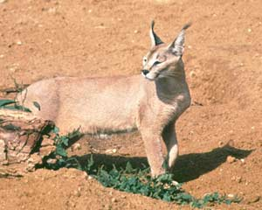j0215607

קָ

j0215358MCj02327030000[1][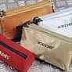](http://www.ynet.co.il/PicServer/131078/c_a.jpg)

MCj03561510000[1]

שָׁ

j0330623j0238218

j0246137j0215230j0301442

תָּ

j0215149



MCj03914580000[1]j0237615j0281102

רָ

j0237590MCj02322280000[1]



j0312174j0215003MCj03512050000[1]

j0240599j0305299