אָדָם

|  |  |  |  |  |
| --- | --- | --- | --- | --- |
| דָּג | אָדָם | דָּג | אָדָם | דַּיָּג |
| אֲגַם | אָדָם | גַּל | אָדָם | אָדָם |
| גַּל | דַּיָּג | חַכָּה | אָדָם | דָּג |
| חַכָּה | זָהָב | אֲגַם | דַּיָּג | גַּל |
| דָּג | חַכָּה | דַּיָּג | אָדָם | דַּיָּג |

אָדָם

C:\Documents and Settings\User\Local Settings\Temporary Internet Files\Content.IE5\AKH6B8CY\MC900435302[1].wmfC:\Documents and Settings\User\Local Settings\Temporary Internet Files\Content.IE5\CWIQILRB\MC900241625[1].wmf

C:\Documents and Settings\User\Local Settings\Temporary Internet Files\Content.IE5\CWIQILRB\MC900111382[1].wmfC:\Documents and Settings\User\Local Settings\Temporary Internet Files\Content.IE5\N68EO6DH\MC900295773[1].wmf

אָדָם בָּא לַיָּם



C:\Documents and Settings\User\Local Settings\Temporary Internet Files\Content.IE5\2V154BNH\MCj04119980000[1].wmf



אִמָא בָּאָה לַיָּם



C:\Documents and Settings\User\Local Settings\Temporary Internet Files\Content.IE5\2V154BNH\MCj04119980000[1].wmf



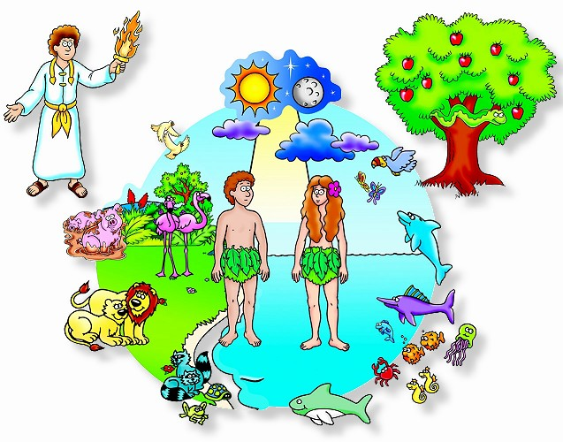אָדָם וְחַוָּה

אָדָם וְחַוָּה בַּגַּן

[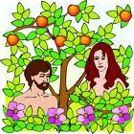](http://www.google.co.il/imgres?imgurl=http://ks.hinuch.net/NR/rdonlyres/D581D0E7-1B79-46B9-AF3D-9110CC709D17/0/%D7%90%D7%93%D7%9D%D7%95%D7%97%D7%95%D7%942.jpg&imgrefurl=http://ks.hinuch.net/web/ofira/%D7%9E%D7%A7%D7%A6%D7%95%D7%A2%D7%95%D7%AA+%D7%94%D7%9C%D7%99%D7%9E%D7%95%D7%93/%D7%AA%D7%95%D7%A8%D7%94/%D7%A1%D7%A4%D7%A8+%D7%91%D7%A8%D7%90%D7%A9%D7%99%D7%AA/%D7%92%D7%9F+%D7%91%D7%A2%D7%93%D7%9F/&usg=__2S75aahtk-v3GPrmSDB3XCx0rbE=&h=720&w=720&sz=125&hl=iw&start=5&sig2=WKe0fEbvH288NcErexQH-g&zoom=1&itbs=1&tbnid=qgxI2N_z6eHVxM:&tbnh=140&tbnw=140&prev=/images?q=%D7%90%D7%93%D7%9D+%D7%95%D7%97%D7%95%D7%94&hl=iw&gbv=2&tbs=isch:1&ei=DMCZTISPDpHQjAeXzIntDw)