MCj03264920000[1]MCj03256000000[1]MCAN00583_0000[1][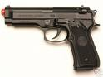](http://images.google.com/imgres?imgurl=http://www.goop.co.il/Goop/forums\Uploads\save\image632703529664218750.jpg&imgrefurl=http://www.goop.co.il/Goop/forums/ShowPost.aspx?PostID=148734&h=300&w=400&sz=17&hl=iw&start=40&sig2=gIgHxZjrSpxmA1DoP7LkJg&tbnid=4jZrtgeM_8NwzM:&tbnh=93&tbnw=124&ei=JulOR_32K4LAgQOrsZ2DCA&prev=/images?q=%D7%90%D7%A7%D7%93%D7%97&start=20&gbv=2&ndsp=20&svnum=10&hl=iw&sa=N)MCj03568930000[1]MCj04153020000[1]HH002546MCj03209860000[1]MCj02942540000[1]MCj02508160000[1]MCj03503890000[1]MCj03458540000[1]

# א

**ג בב**

**ב בב**

**א בב**



MCj04153020000[1]MCj03256000000[1]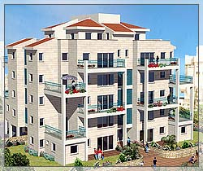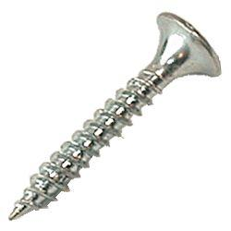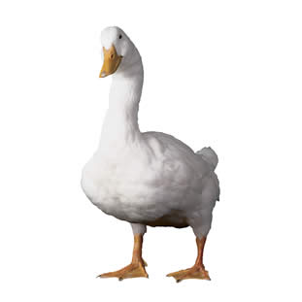MCj02942540000[1] MCj03503890000[1]MCj03458540000[1]

# ב

[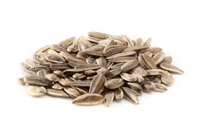](http://www.google.co.il/imgres?hl=iw&biw=1311&bih=554&tbm=isch&tbnid=907uSTFYd09eEM:&imgrefurl=http://www.gafula.co.il/index.php/products/greinim-whvrim.html&docid=yBVImBFqtjEm1M&imgurl=http://www.gafula.co.il/media/catalog/product/cache/1/image/9df78eab33525d08d6e5fb8d27136e95/1/1/11_img_5627_1.jpg&w=1200&h=800&ei=ceMPUOLNKsXV0QWh54GIAg&zoom=1&iact=hc&vpx=86&vpy=156&dur=970&hovh=183&hovw=275&tx=173&ty=129&sig=117963702141077709094&page=2&tbnh=165&tbnw=265&start=21&ndsp=15&ved=1t:429,r:9,s:21,i:165)C:\Users\PURIT\AppData\Local\Microsoft\Windows\Temporary Internet Files\Content.IE5\D8N1ZS7J\MC900238178[1].wmfMCj02942540000[1]MCj03256000000[1]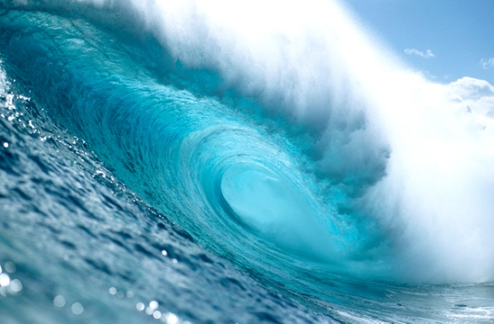[](http://www.google.co.il/imgres?hl=iw&biw=1311&bih=554&tbm=isch&tbnid=2H1riSxcipsUMM:&imgrefurl=http://www.hdm.co.il/articlesread-read-heb-382.html&docid=hsIxEmiCccqvmM&imgurl=http://www.hdm.co.il/prew_image.php?image=ufiles/article_image_1321120034.jpg&watermark_text=&watermark_color=000000&font_size=12&maxim_size=300&w=291&h=300&ei=td8PULO7KMrL0QW4HQ&zoom=1&iact=hc&vpx=727&vpy=208&dur=1334&hovh=228&hovw=221&tx=151&ty=105&sig=117963702141077709094&page=4&tbnh=158&tbnw=153&start=40&ndsp=15&ved=1t:429,r:11,s:40,i:302)C:\Users\PURIT\AppData\Local\Microsoft\Windows\Temporary Internet Files\Content.IE5\XE5U7KFR\MC900356151[1].wmf MCj03503890000[1]

# ג

MCj04246860000[1]MCj04283450000[1]

*flag2*

MCj03264920000[1]MCj03306230000[1]*MCj04284030000[1]*MCj01109020000[1]MCj04043450000[1]*MCj04133120000[1]*MCj02381030000[1][](http://images.google.com/imgres?imgurl=http://www.pcon.co.il/data/images/hed_rej/072105_fish_depression.gif&imgrefurl=http://www.pcon.co.il/v5/ChosenPikantItem.asp?id0=777&h=177&w=190&sz=9&hl=iw&start=3&tbnid=7qCR7tOHij0n9M:&tbnh=96&tbnw=103&prev=/images?q=%D7%93%D7%92&gbv=2&svnum=10&hl=iw&sa=G)MCj01113660000[1]*MCj03561050000[1]*[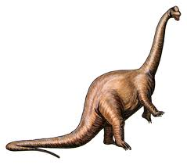](http://images.google.com/imgres?imgurl=http://www.talpiot.macam98.ac.il/actual/jafa/jaf/main/dino/apato.gif&imgrefurl=http://www.talpiot.macam98.ac.il/actual/jafa/jaf/main/dino/dinomain.htm&h=413&w=468&sz=43&hl=iw&start=170&tbnid=QoLziS1dgC0deM:&tbnh=113&tbnw=128&prev=/images?q=%D7%93%D7%99%D7%A0%D7%95%D7%96%D7%90%D7%95%D7%A8&start=160&gbv=2&ndsp=20&svnum=10&hl=iw&sa=N)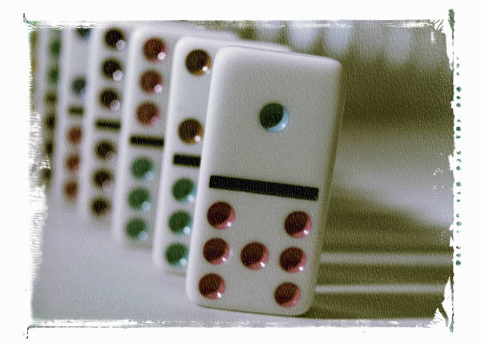MCj02956300000[2]MCj02933800000[1]

**ה בב**

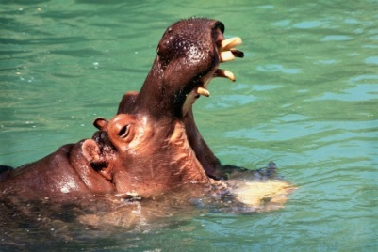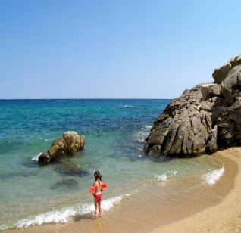C:\Documents and Settings\User\Local Settings\Temporary Internet Files\Content.IE5\BJV688B9\MCj01561690000[1].wmf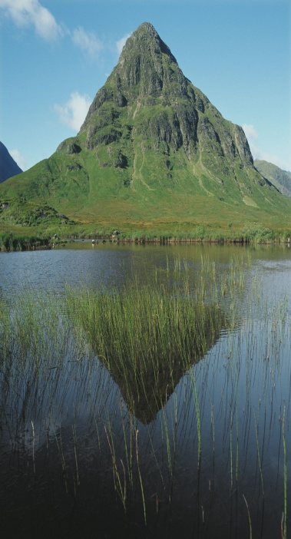

MCj03357710000[1]

MC900310928[1]C:\Documents and Settings\User\Local Settings\Temporary Internet Files\Content.IE5\7SBA55HE\MC900252343[1].wmfMCj03357710000[1]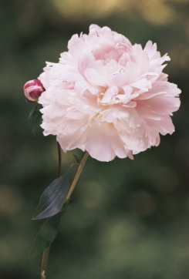MC900310928[1]C:\Documents and Settings\User\Local Settings\Temporary Internet Files\Content.IE5\7SBA55HE\MC900192167[1].wmfC:\Documents and Settings\User\Local Settings\Temporary Internet Files\Content.IE5\4HZMEG19\MC900232872[1].wmf

MCj03357710000[1]MC900310928[1]C:\Documents and Settings\User\Local Settings\Temporary Internet Files\Content.IE5\4HZMEG19\MC900232872[1].wmfC:\Documents and Settings\User\Local Settings\Temporary Internet Files\Content.IE5\7SBA55HE\MC900252343[1].wmfC:\Documents and Settings\User\Local Settings\Temporary Internet Files\Content.IE5\7SBA55HE\MC900192167[1].wmf

MCj03357710000[1]C:\Documents and Settings\User\Local Settings\Temporary Internet Files\Content.IE5\7SBA55HE\MC900320000[1].wmfC:\Documents and Settings\User\Local Settings\Temporary Internet Files\Content.IE5\BFOV3DZT\MC900350368[1].wmfC:\Documents and Settings\User\Local Settings\Temporary Internet Files\Content.IE5\7SBA55HE\MC900192898[1].wmf[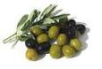](http://www.google.co.il/imgres?imgurl=http://www.syt.co.il/uploads/5219-%D7%96%D7%99%D7%AA%D7%99%D7%9D.jpg&imgrefurl=http://www.syt.co.il/show_news_article.asp?id=1653&h=307&w=450&sz=16&tbnid=607rrWXNIlFGfM:&tbnh=87&tbnw=127&prev=/images?q=%D7%96%D7%99%D7%AA%D7%99%D7%9D&hl=iw&usg=__GfRsTmibvT9i7lb0uZvmlwxUcyM=&sa=X&ei=faBeTN_KD8TfOLKuwL0J&ved=0CB0Q9QEwAw)C:\Documents and Settings\User\Local Settings\Temporary Internet Files\Content.IE5\BFOV3DZT\MC900197387[1].wmf

C:\Documents and Settings\User\Local Settings\Temporary Internet Files\Content.IE5\9ZPOD99B\MC900129636[1].wmfC:\Documents and Settings\User\Local Settings\Temporary Internet Files\Content.IE5\ZO87DVZM\MC900359149[1].wmfC:\Documents and Settings\User\Local Settings\Temporary Internet Files\Content.IE5\7SBA55HE\MC900192898[1].wmfC:\Documents and Settings\User\Local Settings\Temporary Internet Files\Content.IE5\INBNL0IK\MC900301206[1].wmf[](http://www.google.co.il/imgres?imgurl=http://www.orianit.edu-negev.gov.il/briutcm/cp/homepage/Images/%D7%97%D7%A1%D7%94.jpg&imgrefurl=http://www.orianit.edu-negev.gov.il/briutcm/cp/homepage/tofesperotyerakot.htm&usg=__mF9x7DdyFoEQq8CJAeUYmTT_Awg=&h=147&w=110&sz=5&hl=iw&start=4&itbs=1&tbnid=xgX5N1MLJzpKAM:&tbnh=95&tbnw=71&prev=/images?q=%D7%97%D7%A1%D7%94&hl=iw&sa=G&gbv=2&tbs=isch:1)C:\Documents and Settings\User\Local Settings\Temporary Internet Files\Content.IE5\7SBA55HE\MC900320000[1].wmf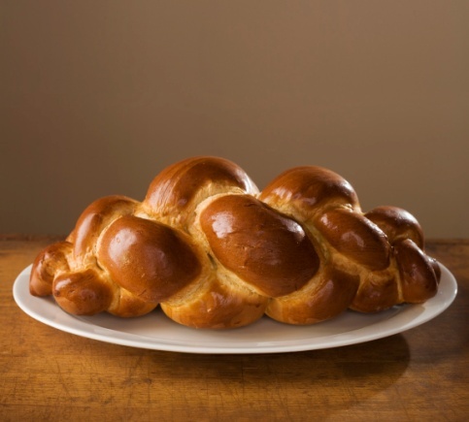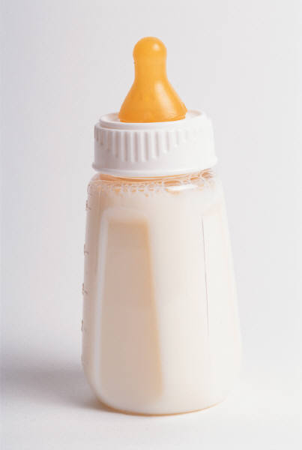C:\Documents and Settings\User\Local Settings\Temporary Internet Files\Content.IE5\BFOV3DZT\MC900350368[1].wmfC:\Documents and Settings\User\Local Settings\Temporary Internet Files\Content.IE5\7AG0MT6Z\MC900301442[1].wmf

C:\Documents and Settings\User\Local Settings\Temporary Internet Files\Content.IE5\9ZPOD99B\MC900361652[1].wmfC:\Documents and Settings\User\Local Settings\Temporary Internet Files\Content.IE5\7AG0MT6Z\MC900083257[1].wmfC:\Documents and Settings\User\Local Settings\Temporary Internet Files\Content.IE5\J1X0H1D4\MC900353849[1].wmf[](http://images.google.com/imgres?imgurl=http://www.hilula.net/data/Images/%D7%A4%D7%A8%D7%A4%D7%A8%20%D7%92%D7%93%D7%95%D7%9C.jpg&imgrefurl=http://www.hilula.net/Site/pages/catalog.asp&h=427&w=640&sz=50&hl=iw&start=23&tbnid=Gmg6ut-MdRaJSM:&tbnh=91&tbnw=137&prev=/images?q=%D7%A4%D7%A8%D7%A4%D7%A8&start=20&gbv=2&ndsp=20&svnum=10&hl=iw&sa=N)[](http://images.google.com/imgres?imgurl=http://www.1-language.com/eslflashcards/images/carrot.jpg&imgrefurl=http://www.snopi.com/enc/values/value451.asp&h=900&w=600&sz=24&hl=iw&start=1&tbnid=ugYe9NT_B2R0aM:&tbnh=146&tbnw=97&prev=/images?q=%D7%92%D7%96%D7%A8&gbv=2&svnum=10&hl=iw&sa=G)[](http://images.google.co.il/imgres?imgurl=http://www.upsite.co.il/uploaded/images/297_1690b3026e383f010dc4e56a1c175e45.gif&imgrefurl=http://www.sadna.co.il/index.php?categoryId=5969&h=332&w=319&sz=48&hl=iw&start=1&sig2=_cceyPPZ2prjxIwe56roOA&tbnid=LWC7jN6nNWl8IM:&tbnh=119&tbnw=114&ei=P3UoSMyMG4ieswLNneCWCg&prev=/images?q=%D7%A2%D7%9C%D7%94&gbv=2&hl=iw)

C:\Documents and Settings\User\Local Settings\Temporary Internet Files\Content.IE5\9ZPOD99B\MC900232612[1].wmf

[](http://www.google.co.il/imgres?hl=iw&biw=1311&bih=554&tbm=isch&tbnid=2H1riSxcipsUMM:&imgrefurl=http://www.hdm.co.il/articlesread-read-heb-382.html&docid=hsIxEmiCccqvmM&imgurl=http://www.hdm.co.il/prew_image.php?image=ufiles/article_image_1321120034.jpg&watermark_text=&watermark_color=000000&font_size=12&maxim_size=300&w=291&h=300&ei=td8PULO7KMrL0QW4HQ&zoom=1&iact=hc&vpx=727&vpy=208&dur=1334&hovh=228&hovw=221&tx=151&ty=105&sig=117963702141077709094&page=4&tbnh=158&tbnw=153&start=40&ndsp=15&ved=1t:429,r:11,s:40,i:302)MCj02942540000[1][](http://www.google.co.il/url?sa=i&source=images&cd=&cad=rja&docid=7VaytcjYkN0G5M&tbnid=yT_29BcbdflcKM:&ved=0CAgQjRwwAA&url=http://bestclipartblog.com/23-moon-clip-art.html/moon-clip-art-11&ei=ajqNUo7eKuq90QXapYGQBw&psig=AFQjCNEcUU3JIZWaf8pSZ_DvE3yA5X9twg&ust=1385073642755250)[](http://www.google.co.il/url?sa=i&rct=j&q=&esrc=s&frm=1&source=images&cd=&cad=rja&docid=QxtZfa1XA0S1dM&tbnid=l6tBuSIOFlTjSM:&ved=0CAUQjRw&url=http://www.coloring4fun.com/?p=2980&ei=vTmNUpmeCMfH0QXNtYCQBA&bvm=bv.56643336,d.d2k&psig=AFQjCNGVX4iCyXO4sgKY-pDvila-F-Kr-g&ust=1385073371423615)

# כ

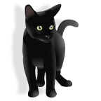C:\Documents and Settings\purit1\Local Settings\Temporary Internet Files\Content.IE5\4R8RYL4Z\MCj02942180000[1].wmfC:\Documents and Settings\purit1\Local Settings\Temporary Internet Files\Content.IE5\4R8RYL4Z\MCj03615400000[1].wmfC:\Documents and Settings\User\Local Settings\Temporary Internet Files\Content.IE5\THZB9355\MC900330633[1].wmfC:\Documents and Settings\purit1\Local Settings\Temporary Internet Files\Content.IE5\N6TO13BF\MCj04107810000[1].wmfC:\Documents and Settings\purit1\Local Settings\Temporary Internet Files\Content.IE5\91828Z1N\MCj03569210000[1].wmf

C:\Documents and Settings\purit1\Local Settings\Temporary Internet Files\Content.IE5\4R8RYL4Z\MCj03448880000[1].wmfC:\Documents and Settings\purit1\Local Settings\Temporary Internet Files\Content.IE5\K5IB4HIF\MCj04133200000[1].wmfC:\Documents and Settings\purit1\Local Settings\Temporary Internet Files\Content.IE5\MDRSDKZ2\MCj02461190000[1].wmf[](http://images.google.com/imgres?imgurl=http://www.1-language.com/eslflashcards/images/carrot.jpg&imgrefurl=http://www.snopi.com/enc/values/value451.asp&h=900&w=600&sz=24&hl=iw&start=1&tbnid=ugYe9NT_B2R0aM:&tbnh=146&tbnw=97&prev=/images?q=%D7%92%D7%96%D7%A8&gbv=2&svnum=10&hl=iw&sa=G)

C:\Documents and Settings\purit1\Local Settings\Temporary Internet Files\Content.IE5\MDRSDKZ2\MCj02461190000[1].wmfC:\Documents and Settings\purit1\Local Settings\Temporary Internet Files\Content.IE5\0RW7MS0Q\MCj04355840000[1].wmf[](http://images.google.com/imgres?imgurl=http://www.1-language.com/eslflashcards/images/carrot.jpg&imgrefurl=http://www.snopi.com/enc/values/value451.asp&h=900&w=600&sz=24&hl=iw&start=1&tbnid=ugYe9NT_B2R0aM:&tbnh=146&tbnw=97&prev=/images?q=%D7%92%D7%96%D7%A8&gbv=2&svnum=10&hl=iw&sa=G)C:\Documents and Settings\purit1\Local Settings\Temporary Internet Files\Content.IE5\0RW7MS0Q\MCj04078180000[1].wmfC:\Documents and Settings\purit1\Local Settings\Temporary Internet Files\Content.IE5\4R8RYL4Z\MCj03448880000[1].wmf

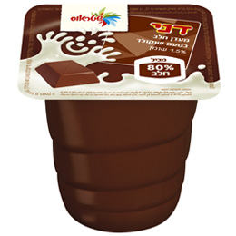[](http://images.google.com/imgres?imgurl=http://www.1-language.com/eslflashcards/images/carrot.jpg&imgrefurl=http://www.snopi.com/enc/values/value451.asp&h=900&w=600&sz=24&hl=iw&start=1&tbnid=ugYe9NT_B2R0aM:&tbnh=146&tbnw=97&prev=/images?q=%D7%92%D7%96%D7%A8&gbv=2&svnum=10&hl=iw&sa=G)[](http://1.bp.blogspot.com/-GmEbdA6rZak/TlnGsr-_wVI/AAAAAAAAAF0/g0eKfpUvV9Q/s1600/cartoon-king-18.gif)C:\Documents and Settings\purit1\Local Settings\Temporary Internet Files\Content.IE5\K5IB4HIF\MCj04133200000[1].wmfC:\Documents and Settings\purit1\Local Settings\Temporary Internet Files\Content.IE5\4R8RYL4Z\MCj03448880000[1].wmfC:\Documents and Settings\purit1\Local Settings\Temporary Internet Files\Content.IE5\MDRSDKZ2\MCj02461190000[1].wmfC:\Documents and Settings\purit1\My Documents\purit\shizaf\כיתה א\אב\די_נט - אותיות מקווקוות_files\Mem1.jpg

C:\Documents and Settings\purit1\Local Settings\Temporary Internet Files\Content.IE5\N6TO13BF\MCj03244640000[1].wmfC:\Documents and Settings\purit1\Local Settings\Temporary Internet Files\Content.IE5\Q70BU3I1\MCj03453340000[1].wmfC:\Documents and Settings\purit1\Local Settings\Temporary Internet Files\Content.IE5\W5Y7WLMN\MCAN00585_0000[1].wmf

# נ

C:\Documents and Settings\purit1\Local Settings\Temporary Internet Files\Content.IE5\91828Z1N\MCj04040410000[1].wmf

C:\Documents and Settings\purit1\Local Settings\Temporary Internet Files\Content.IE5\0TQZWXAZ\MCj04104690000[1].wmf

C:\Documents and Settings\purit1\Local Settings\Temporary Internet Files\Content.IE5\91828Z1N\MCj03569210000[1].wmfC:\Documents and Settings\purit1\Local Settings\Temporary Internet Files\Content.IE5\MDRSDKZ2\MCj02461190000[1].wmf

C:\Documents and Settings\User\Local Settings\Temporary Internet Files\Content.IE5\BFOV3DZT\MC900350368[1].wmf

j0198939



ס

[](http://www.google.co.il/url?sa=i&rct=j&q=&esrc=s&frm=1&source=images&cd=&cad=rja&docid=iWKVEznvn4m7FM&tbnid=ZcEwoRoHh6nJzM:&ved=0CAUQjRw&url=http://www.lpl.co.il/coloringpages/coloring-animals8.aspx&ei=Z5kWUceGDsvWsgaxyYDQDw&psig=AFQjCNGrfREyAFY8zQaCd1kCXzV1ADEBig&ust=1360521947457830)



j0233666

j0290435



j0350389[](http://www.google.co.il/url?sa=i&rct=j&q=&esrc=s&frm=1&source=images&cd=&cad=rja&docid=H5zuMGcV2rFNCM&tbnid=5jw6MZ5JFw9USM:&ved=0CAUQjRw&url=http://www.how-to-draw-cartoons-online.com/cartoon-mouse.html&ei=HOmcUerGNIWR0AXqyYDICw&psig=AFQjCNEWP0B1d-uY0NqwXIRs-jNe_sfyYA&ust=1369324184844462)[](http://blog.daum.net/uslie/32)

[](http://www.google.co.il/url?sa=i&rct=j&q=&esrc=s&frm=1&source=images&cd=&cad=rja&docid=2So_hLof1wWKtM&tbnid=ociOFqVzKe6iQM:&ved=0CAUQjRw&url=http://www.how-to-draw-cartoons-online.com/cartoon-clouds.html&ei=XumcUemNB6ez0QX0-4DwDw&psig=AFQjCNETtKi2ErfjH3MkJfmGFJiyYFgV7Q&ust=1369324237563155)[](http://images.google.com/imgres?imgurl=http://www.1-language.com/eslflashcards/images/carrot.jpg&imgrefurl=http://www.snopi.com/enc/values/value451.asp&h=900&w=600&sz=24&hl=iw&start=1&tbnid=ugYe9NT_B2R0aM:&tbnh=146&tbnw=97&prev=/images?q=%D7%92%D7%96%D7%A8&gbv=2&svnum=10&hl=iw&sa=G)

[](http://images.google.co.il/imgres?imgurl=http://www.upsite.co.il/uploaded/images/297_1690b3026e383f010dc4e56a1c175e45.gif&imgrefurl=http://www.sadna.co.il/index.php?categoryId=5969&h=332&w=319&sz=48&hl=iw&start=1&sig2=_cceyPPZ2prjxIwe56roOA&tbnid=LWC7jN6nNWl8IM:&tbnh=119&tbnw=114&ei=P3UoSMyMG4ieswLNneCWCg&prev=/images?q=%D7%A2%D7%9C%D7%94&gbv=2&hl=iw)

[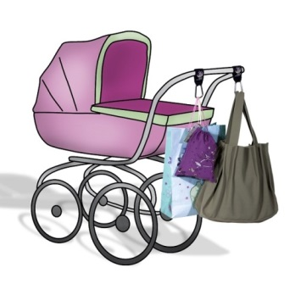](http://www.google.co.il/url?sa=i&rct=j&q=&esrc=s&frm=1&source=images&cd=&cad=rja&docid=wznvDPBroj9_YM&tbnid=ZKsopfLFg-08JM:&ved=0CAUQjRw&url=http://www.agalease-baby.co.il/?p=2042&ei=4iidUeyfN8SbtAbWgoG4Bw&psig=AFQjCNFI3W_ipJ8bViUzgeeBZ0pocTs5Vw&ust=1369340442528289)

[](http://images.google.com/imgres?imgurl=http://www.hilula.net/data/Images/%D7%A4%D7%A8%D7%A4%D7%A8%20%D7%92%D7%93%D7%95%D7%9C.jpg&imgrefurl=http://www.hilula.net/Site/pages/catalog.asp&h=427&w=640&sz=50&hl=iw&start=23&tbnid=Gmg6ut-MdRaJSM:&tbnh=91&tbnw=137&prev=/images?q=%D7%A4%D7%A8%D7%A4%D7%A8&start=20&gbv=2&ndsp=20&svnum=10&hl=iw&sa=N)[](http://images.google.com/imgres?imgurl=http://img2.tapuz.co.il/communafiles/10462259.png&imgrefurl=http://www.tapuz.co.il/blog/userBlog.asp?pagenumber=9&passok=yes&FolderName=dontwantlive&blogId=30833&tagname=&h=358&w=453&sz=366&hl=iw&start=2&tbnid=Rr_x6EVgv8NO9M:&tbnh=100&tbnw=127&prev=/images?q=%D7%97%D7%AA%D7%95%D7%9C&gbv=2&svnum=10&hl=iw&sa=G)

C:\Documents and Settings\purit1\My Documents\purit\shizaf\כיתה א\אב\די_נט - אותיות מקווקוות_files\Pey1.jpg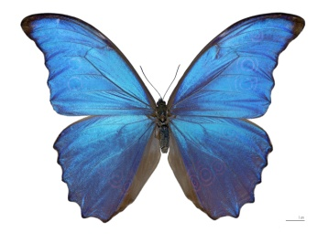

[](http://www.google.co.il/imgres?hl=iw&noj=1&tbm=isch&tbnid=_HP8TN0wFA_IAM:&imgrefurl=http://www.wallashops.co.il/a/ap.aspx?pi=ON30826142&docid=TUmkfuPcBRgO8M&imgurl=http://ypk.cs4u.co.il/mall_product_images/auction_product/ON30826142.jpg&w=300&h=300&ei=MEjuUti5EuzW4ASe4ICgAg&zoom=1&iact=rc&dur=750&page=1&start=0&ndsp=9&ved=0CFQQrQMwAA)[](http://images.google.com/imgres?imgurl=http://www.1-language.com/eslflashcards/images/carrot.jpg&imgrefurl=http://www.snopi.com/enc/values/value451.asp&h=900&w=600&sz=24&hl=iw&start=1&tbnid=ugYe9NT_B2R0aM:&tbnh=146&tbnw=97&prev=/images?q=%D7%92%D7%96%D7%A8&gbv=2&svnum=10&hl=iw&sa=G)C:\Documents and Settings\purit1\Local Settings\Temporary Internet Files\Content.IE5\MDRSDKZ2\MCj02461190000[1].wmfC:\Documents and Settings\purit1\Local Settings\Temporary Internet Files\Content.IE5\4R8RYL4Z\MCj03448880000[1].wmfC:\Documents and Settings\purit1\Local Settings\Temporary Internet Files\Content.IE5\K5IB4HIF\MCj04133200000[1].wmf

[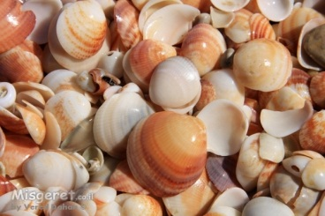](http://www.google.co.il/url?sa=i&rct=j&q=&esrc=s&frm=1&source=images&cd=&cad=rja&docid=k9xztSM9UYCT1M&tbnid=wpENmf44RqN2kM:&ved=0CAUQjRw&url=http://my.misgeret.co.il/vereddahan/ShowPic.php?pic=109092&ei=FZkWUc_bK5HLsgaX0oHQCw&psig=AFQjCNF3KKV7NzK7p9v8Atz-DXt6RAa0Pg&ust=1360521857075708)C:\Documents and Settings\User\Local Settings\Temporary Internet Files\Content.IE5\BFOV3DZT\MC900350368[1].wmf

C:\Documents and Settings\User\Local Settings\Temporary Internet Files\Content.IE5\7SBA55HE\MC900192898[1].wmf

צ

C:\Documents and Settings\User\Local Settings\Temporary Internet Files\Content.IE5\ZO87DVZM\MC900359149[1].wmf

[](http://www.google.co.il/url?sa=i&rct=j&q=&esrc=s&frm=1&source=images&cd=&cad=rja&docid=iWKVEznvn4m7FM&tbnid=ZcEwoRoHh6nJzM:&ved=0CAUQjRw&url=http://www.lpl.co.il/coloringpages/coloring-animals8.aspx&ei=Z5kWUceGDsvWsgaxyYDQDw&psig=AFQjCNGrfREyAFY8zQaCd1kCXzV1ADEBig&ust=1360521947457830)

[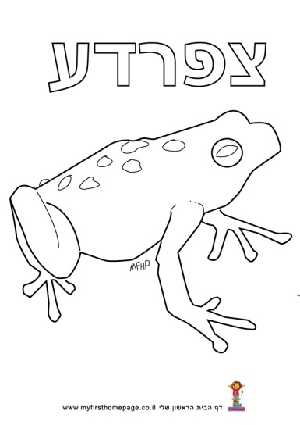](http://www.google.co.il/url?sa=i&rct=j&q=&esrc=s&frm=1&source=images&cd=&cad=rja&docid=vaQ6f_0JyuGxMM&tbnid=86fODPXfFkvfPM:&ved=0CAUQjRw&url=http://www.myfirsthomepage.co.il/hagim/download318.htm&ei=npgWUaHyFYXltQarloGIDg&psig=AFQjCNFtMWSKH4OPU3M406pyeZUHk82RZw&ust=1360521691219418)



C:\Documents and Settings\User\Local Settings\Temporary Internet Files\Content.IE5\7SBA55HE\MC900320000[1].wmf

**ק**

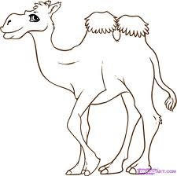[](javascript:edit(84986))[](http://images.google.co.il/imgres?imgurl=http://www.marynroos.com/blog/monkey_test.jpg&imgrefurl=http://baronesss2.blogspot.com/2006/09/monkey-time.html&usg=__aCxjOy-ACXh_8NSofrynsQdbtiY=&h=341&w=375&sz=217&hl=iw&start=22&tbnid=h4E3Wby8OaM0xM:&tbnh=111&tbnw=122&prev=/images?q=monkey&start=21&gbv=2&hl=iw&safe=vss&sa=N)

[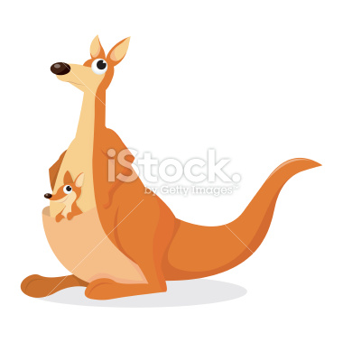](http://www.google.co.il/url?sa=i&rct=j&q=&esrc=s&frm=1&source=images&cd=&cad=rja&docid=kii4EhomEVwgQM&tbnid=sZvxx9n8Zij-iM:&ved=0CAUQjRw&url=http://portuguesbrasileiro.istockphoto.com/stock-illustration-12552092-cartoon-kangaroo-and-joey.php&ei=uUgwUfWnCYT0sga9n4HwCQ&psig=AFQjCNH0xBQw2HfDFPFHaeg5SCkqGEqSgQ&ust=1362205232057850)

[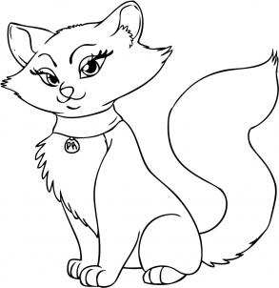](http://www.dragoart.com/tuts/pics/9/2540/11043/how-to-draw-a-cartoon-cat-step-6.jpg)

[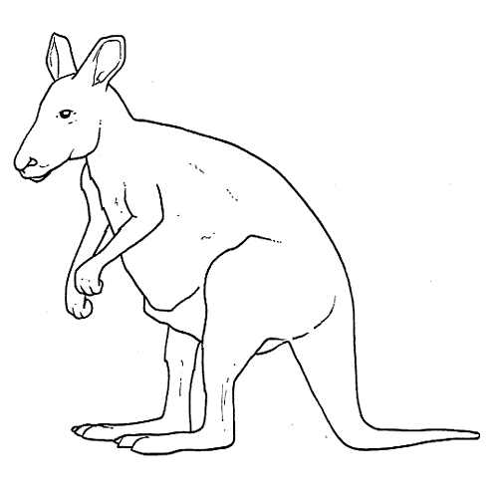](http://www.google.co.il/url?sa=i&rct=j&q=&esrc=s&frm=1&source=images&cd=&cad=rja&docid=RW40RICzb_CfaM&tbnid=DKVRNJ3kCgbLcM:&ved=0CAUQjRw&url=http://www.supernins.com/el-canguro-dibujos-para-colorear-animales-salvajes.html&ei=npgxUcfoJo_FswaJ0YHQBA&psig=AFQjCNFlkpVmyTJnqfCByXoxArMP6Uf75w&ust=1362291226740017)**ק**

**ר**

[](http://images.google.co.il/imgres?imgurl=http://www.kgesher.co.il/image/users/66424/ftp/my_files/DOCTOR.jpg&imgrefurl=http://www.kgesher.co.il/66424/%D7%A9%D7%A2%D7%95%D7%AA-%D7%A4%D7%AA%D7%99%D7%97%D7%94-%D7%95%D7%A7%D7%91%D7%9C%D7%94&usg=__-M9St5fz47nqFG3qPYvi-HDvUr4=&h=1429&w=1462&sz=162&hl=iw&start=13&tbnid=K0ehtlJfwBoZtM:&tbnh=147&tbnw=150&prev=/images?q=%D7%A8%D7%95%D7%A4%D7%90&gbv=2&hl=iw&safe=vss&sa=G)

[](javascript:edit(84986))[](http://images.google.co.il/imgres?imgurl=http://www.marynroos.com/blog/monkey_test.jpg&imgrefurl=http://baronesss2.blogspot.com/2006/09/monkey-time.html&usg=__aCxjOy-ACXh_8NSofrynsQdbtiY=&h=341&w=375&sz=217&hl=iw&start=22&tbnid=h4E3Wby8OaM0xM:&tbnh=111&tbnw=122&prev=/images?q=monkey&start=21&gbv=2&hl=iw&safe=vss&sa=N)





j0198939



ש

[](http://www.google.co.il/url?sa=i&rct=j&q=&esrc=s&frm=1&source=images&cd=&cad=rja&docid=iWKVEznvn4m7FM&tbnid=ZcEwoRoHh6nJzM:&ved=0CAUQjRw&url=http://www.lpl.co.il/coloringpages/coloring-animals8.aspx&ei=Z5kWUceGDsvWsgaxyYDQDw&psig=AFQjCNGrfREyAFY8zQaCd1kCXzV1ADEBig&ust=1360521947457830)



j0238218

j0290435

j0215230j0233052





ת

MCj01503370000[1]

j0233666

